Task 3: Principal Component Analysis

Krescens Kok
Department of Technology, Western Governors University
D600: Statistical Data Mining
Keiona Middleton
2025 October 26

A. Create your subgroup and project in GitLab using the provided web link by doing the following:
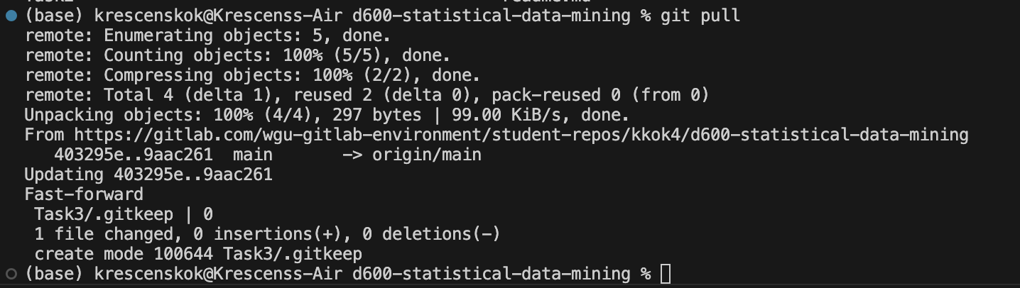
• Clone the project to the IDE.

• Commit with a message and push when you complete each requirement listed in parts D2 through F4.

• Submit a copy of the GitLab repository URL in the "Comments to Evaluator" section when you submit this assessment.
• Submit a copy of the repository branch history retrieved from your repository, which must include the commit messages and dates.

B. Describe the purpose of this data analysis by doing the following:
1. Propose one research question that is relevant to a real-world organizational situation captured in the provided dataset that you will answer using linear regression in the initial model.

Can I use a PCA to identify the principal component that should be used in the linear regression model in order to predict house prices?

2. Define one goal of the data analysis. Ensure that your goal is reasonable within the scope of the scenario and is represented in the available data.

One goal of this data analysis is to determine how well the non-categorical and continuous variables influence house prices using principal component analysis. A PCA is used for dimensionality reduction, preserving the essential information/variables needed for predicting the dependent variable.

C. Explain the reasons for using PCA by doing the following:
1. Explain how PCA can be used to prepare the selected dataset for regression analysis. Include expected outcomes.

A PCA can be used to prepare the selected dataset for regression analysis because it reduces the number of dimensions in large datasets to principal components that retain most of the original information. This is helpful because the model can begin with all the non-categorical independent variables and extract the most important features, thereby reducing model complexity and capturing most of the data's variability (Jolliffe & Cadima, 2016). The expected outcome of a PCA is principal components that are uncorrelated with each other, as well as the explained variance for each component. By the end of this analysis, we will identify all the components that are important for predicting a house price, thereby reducing dimensionality and noise in the model.

2. Summarize one assumption of PCA.

An assumption of PCA is that there are multiple variables used that are continuous (How to Perform a Principal Components Analysis (PCA) in SPSS Statistics | Laerd Statistics, n.d.). Part of this analysis involved removing discrete and categorical variables, while retaining only the continuous variables, which satisfies the assumption of PCA. Additionally, 13 variables will be used for this PCA.

Another assumption of PCA is that PCA assumes linearity between features. The algorithm isn’t best used for capturing non-linear relationships (A Guide to Principal Component Analysis (PCA) for Machine Learning, n.d.). Since it finds linearity between features, the PCA finds directions or principal components that maximize linear variance.

D. Summarize the data preparation process for linear regression analysis by doing the following:
1. Identify the continuous dataset variables that you will need to answer the research question proposed in part B1.

The following features have been removed from the dataset because they are not continuous variables: ‘ID’, ‘Fireplace’, ‘HouseColor’, ‘Garage’, ‘Floors’, ‘Windows’, ‘NumBedrooms’, and ‘IsLuxury’.
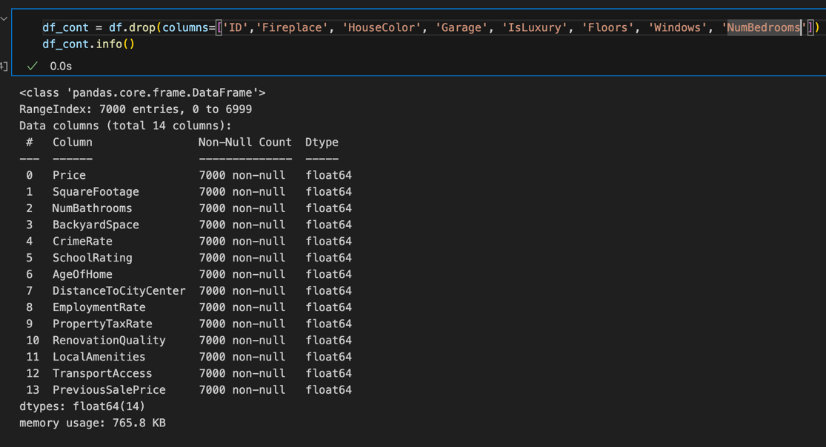
Here are the remaining variables that will be used for the PCA:

2. Standardize the continuous dataset variables identified in part D1. Include a copy of the cleaned dataset.

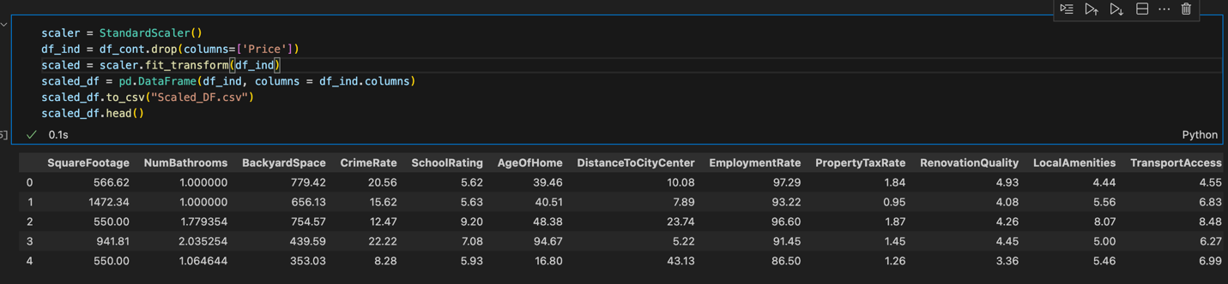

3. Describe the dependent variable and all independent variables from part D1 using descriptive statistics (counts, means, modes, ranges, min/max), including a screenshot of the descriptive statistics output for each of these variables.

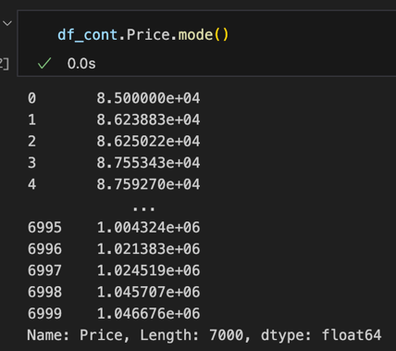
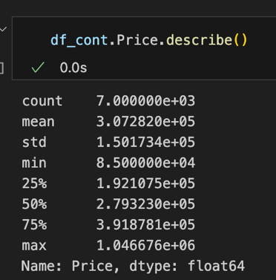
Dependent Variable:

Independent Variables:
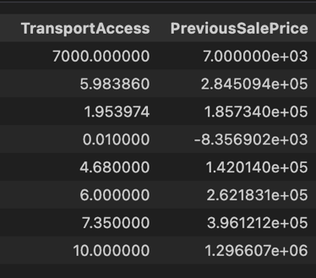
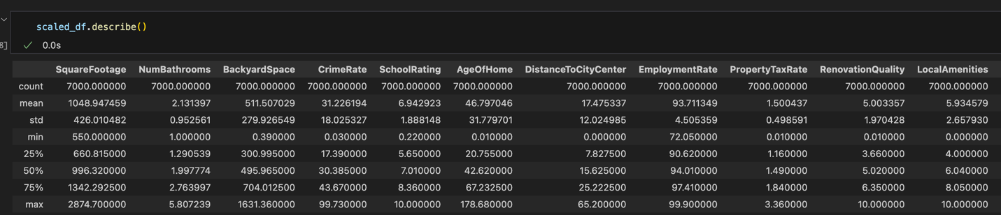

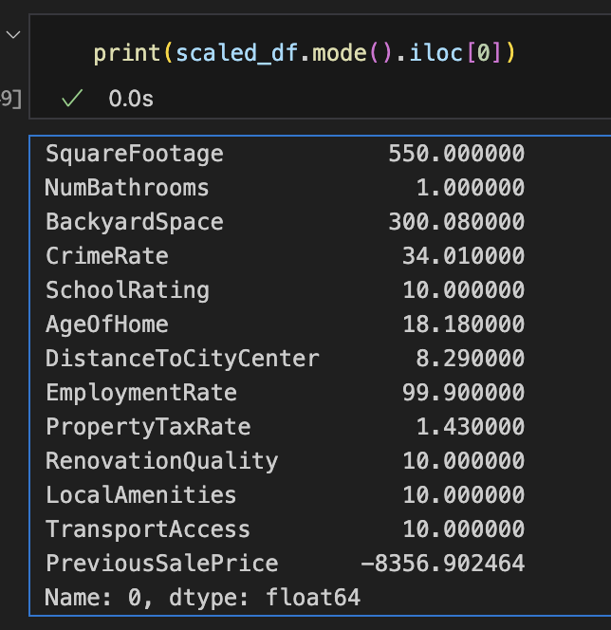

E. Perform PCA by doing the following:
1. Determine the matrix of all the principal components.

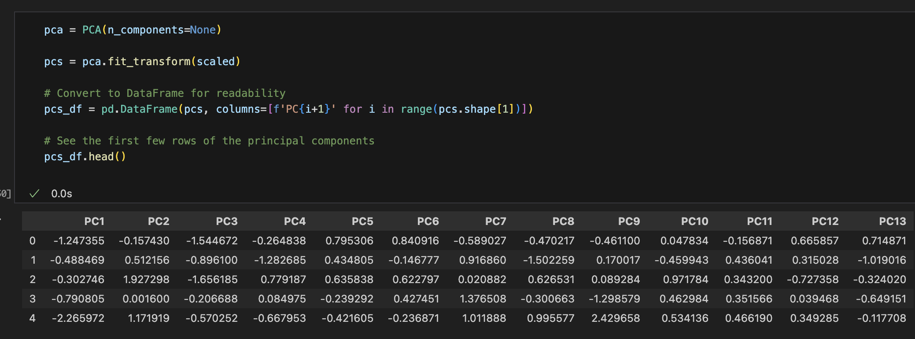

2. Identify the total number of principal components (that should be retained), using the elbow rule or the Kaiser rule. Include a screenshot of the scree plot.

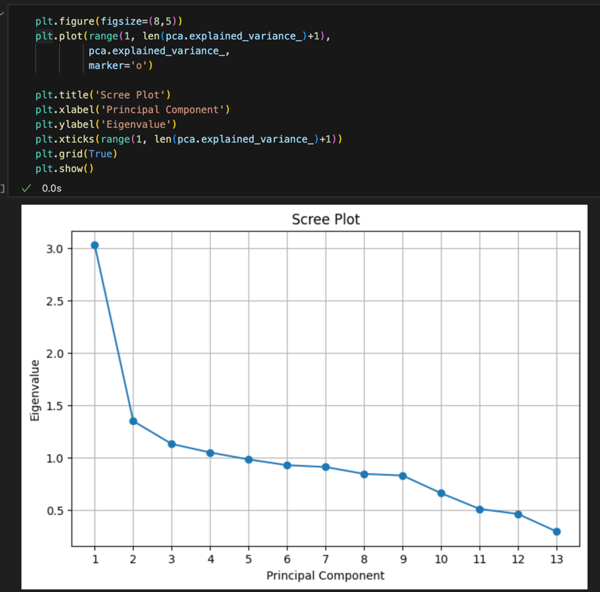
Based on the Kaiser rule, the number of principal components should be 4, as all have an eigenvalue greater than 1 (Toth, 2020).
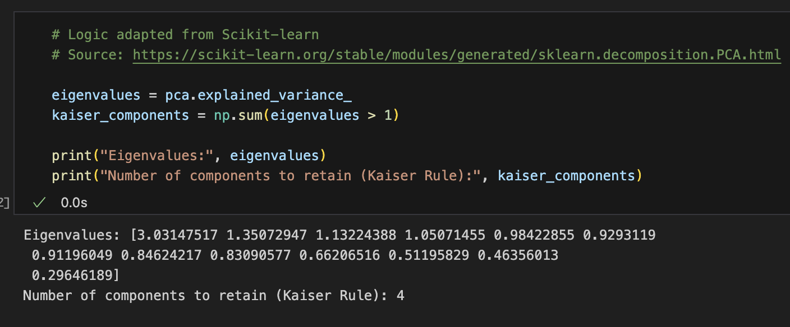

3. Identify the variance of each of the principal components identified in part E2.

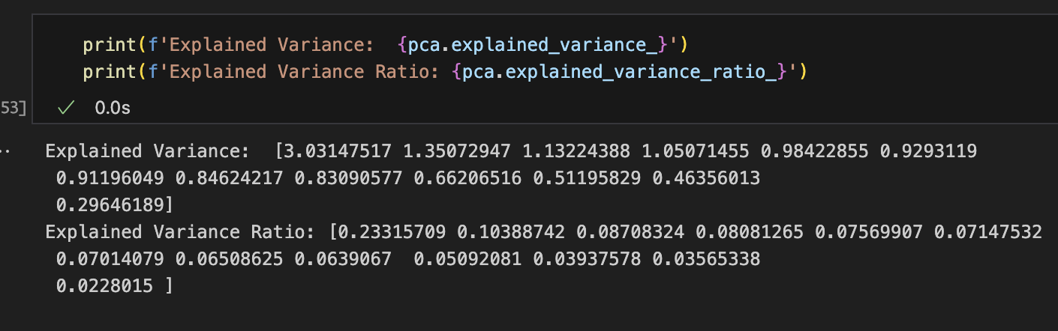

4. Summarize the results of your PCA.

Originally, 13 variables were used for this analysis. Based on the PCA, the Kaiser and elbow tests indicate that 4 principal components should be retained. With these 4 principal components, 50.49% of the variance will be explained. These principal components will now be used for the multiple linear regression model to predict house prices.

F. Perform the data analysis and report on the results by doing the following:
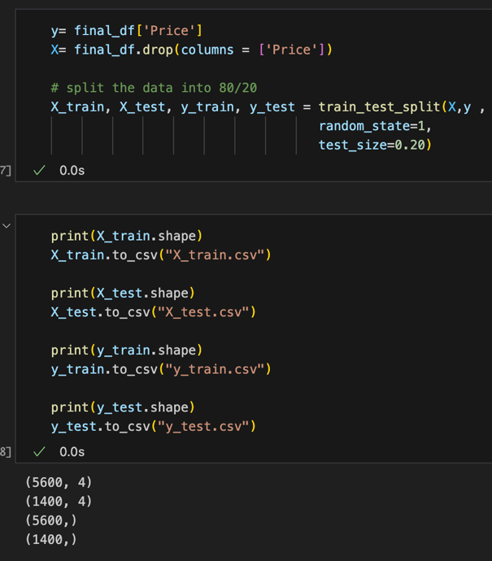
1. Split the data into two datasets, with a larger percentage assigned to the training dataset and a smaller percentage assigned to the test dataset. Provide the file(s).

2. Use the training dataset to create and perform a regression model using regression as a statistical method. Optimize the regression model using a process of your selection, including but not limited to, forward stepwise selection, backward stepwise elimination, and recursive selection. Provide a screenshot of the summary of the optimized model or the following extracted model parameters:
• Adjusted R²
• R²
• F statistics
• Probability F statistics
• coefficient estimates
• p-value of each independent variable

Before optimizing: After optimizing:
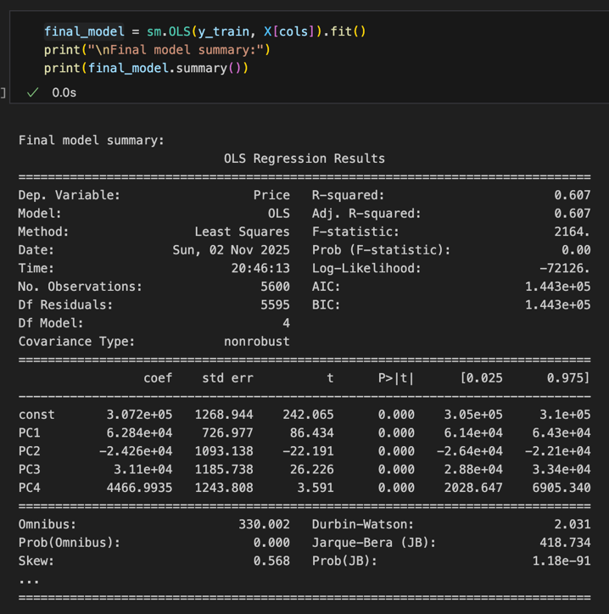
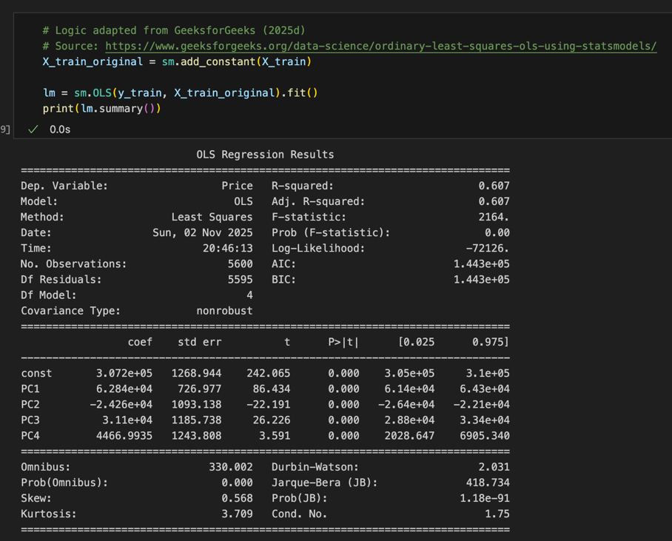

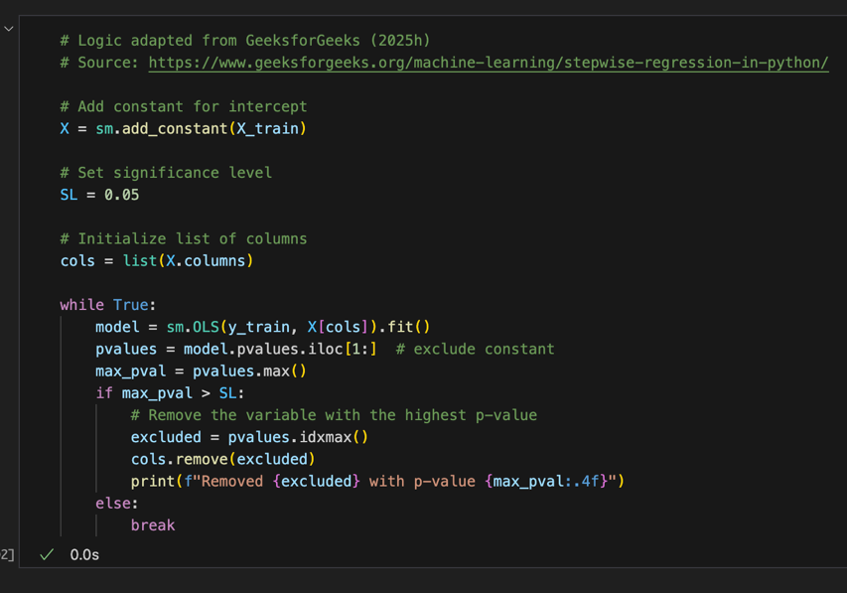
Backward Elimination:
3. Give the mean squared error (MSE) of the optimized model used on the training set.

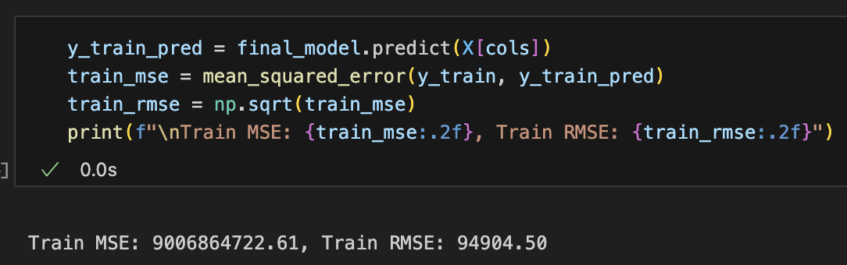
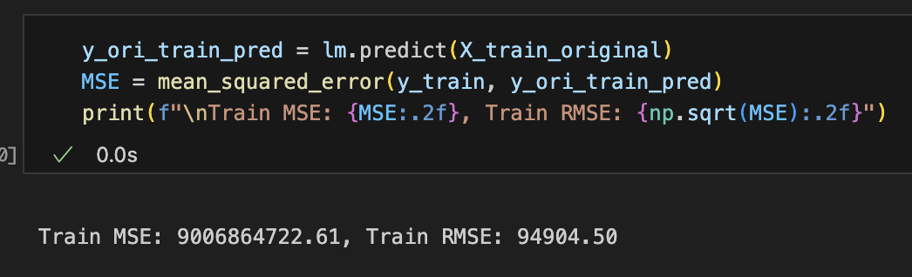
MSE before optimizing: MSE after optimizing:

4. Run the prediction on the test dataset using the optimized regression model from part F2 to give the accuracy of the prediction model based on the mean squared error (MSE).

The ‘cols’ variable contains the principal components that were kept after optimizing the model. Considering the relatively low RMSE, given the context of house prices, the model is fairly accurate.
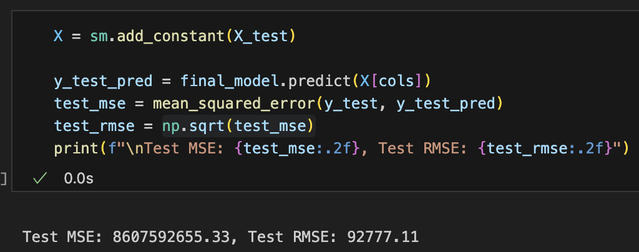

G. Summarize your data analysis by doing the following:
1. List the packages or libraries you have chosen for Python or R and justify how each item on the list supports the analysis.

- import pandas as pd: Used for creating data frames, transforming data frames (e.g. dropping columns), and reading/writing csv files.
- import sys: Used to identify the Python version being used.
- import matplotlib.pyplot as plt: Used for creating the scree plot.
- from sklearn.model_selection import train_test_split: Used to split the data frame into test and train
- from sklearn.metrics import mean_squared_error: Used to get the MSE for the model.
- import statsmodels.api as sm: Used to apply ordinary least square regression on the dataframe to get the summary of the model, which includes the r-squared, F statistic, coefficients, etc…
- from statsmodels.stats.outliers_influence import variance_inflation_factor: Used to check if the variables had multicollinearity.
- from statsmodels.stats.stattools import durbin_watson: Used to identify autocorrelation in the residuals of a regression model. This was important to identify before performing backward elimination.
- import numpy as np: Used for the square root function to get the squared MSE.
- from sklearn.preprocessing import StandardScaler: Used for scaling the data to standardize the values.
- from sklearn.decomposition import PCA: Used to perform the PCA to find the optimal number of principal components

2. Discuss the method used to optimize the model and justification for the approach.

I chose a backward elimination for optimizing the model as it iterates through the features and eliminates the less significant features through a loop and stops once all the features have a significant value of less than .05. Keeping features with a significant value of less than .05 means that there is strong evidence against the null hypothesis and the feature does have an impact on the dependent variable. Although this time, optimizing the model did not change anything, it confirmed that all the principal components originally included in the model have a significant value of less than 0.05.

3. Discuss the verification of assumptions used to create the optimized model.

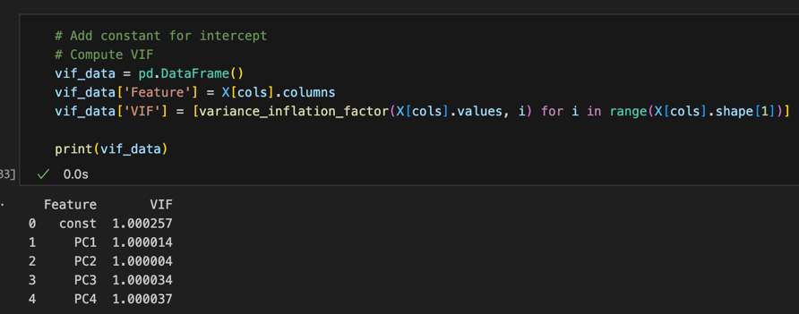
In a linear regression model, there should be a lack of multicollinearity, meaning that independent variables are not highly correlated with one another. To address this, the variance_inflation_factor was used to identify features with a VIF score greater than 15, indicating the presence of multicollinearity. Below, using the variance_inflaction_factor verifies this assumption, showing that all the scores were below 15.

Another assumption of the linear regression model. Independence of errors ensures that the residuals are not correlated with one another, meaning that the error associated with one observation should not influence the error of another observation. The Durbin-Watson statistic verifies this assumption of the linear regression model.
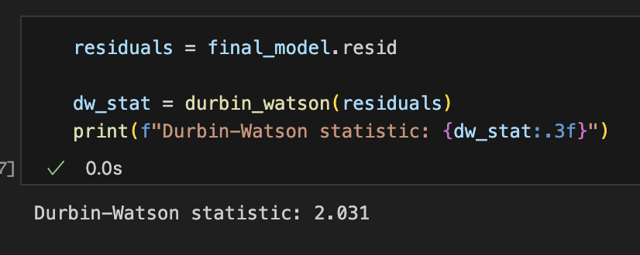
4. Provide the regression equation and discuss the coefficient estimates

price = 307,200 + 62840PC₁- 24260PC₂ + 31100PC₃ + 4466.9935PC₄

If all the independent variables didn’t exist or were 0, the base price for a house would be $307,200.

62840PC₁: This coefficient indicates that for every 1-unit increase in PC₁, the house price is estimated to increase by $62,840.

-24260PC₂: This coefficient means that every time PC₂ increases by 1, the house price is estimated to go down by $24,260.

31100PC₃: This coefficient indicates that every time PC₃ increases by 1, the house price is estimated to increase by $31,100.

4466.9935PC₄: This coefficient means that every time PC₄ increases by 1, the house price is estimated to go up by $4,466.9935.

5. Discuss the model metrics by addressing each of the following:
• the R² and adjusted R² of the training set

The R² value of the training set is .607, and the adjusted R² value is .607.

The R² values explain the proportion of variance in the dependent variable that is explained by the independent variables. So, in this case, 60.7% of the variation is explained by the independent variables. The adjusted R² value is similar to the R² value; however, it adjusts for the number of predictors in the model, penalizing unnecessary complexity. Since both the R² and adjusted R² values are similar, this indicates that there is very little noise in the model, and the model provides a strong fit to the data.

• the comparison of the MSE for the training set to the MSE of the test set

The MSE for the training set is 9006864722.61, while the MSE of the test set is 8607592655.33. The MSE is the average of the squared differences between the predicted and actual values. Since the units are dollars and house prices are typically high, this makes sense that the MSE values are so high. Generally, the lower the MSE value, the better the model.

Taking the root of the MSE value is better for interpretation, as it brings the number back down to scale, since the values were initially squared to prevent negative values. So, the RMSE of the training set is 94,904.50, and the RMSE of the test set is 92,777.11. This means that there’s about a 29% error between the model prediction and the actual house prices for both the training and test sets. Since the test and train RMSE values are close, this means that the model has found a balanced fit that generalizes well to new data.
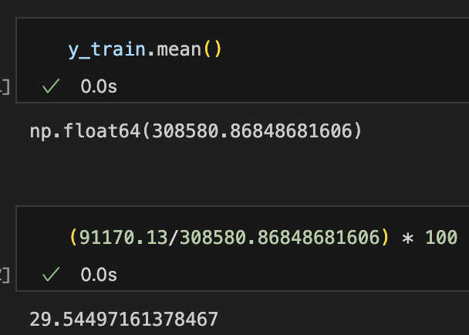
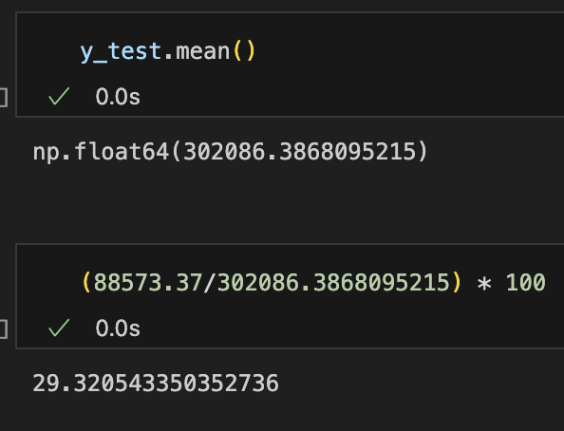

6. Discuss the results and implications of your prediction analysis.

The results reveal that using all 13 variables initially, and then using 4 principal components, yields house predictions that are off by about 29% of the time, with an R² value of 0.607. This represents a reasonable fit, though some of the variation is still influenced by other factors such as neighborhood safety, district quality, or broader market conditions. Since the training and test sets both had a similar RMSE and the same R² value, this shows that the model did not overfit the data and generalizes decently well to unseen data.

The implications of these findings are significant for multiple individuals, especially those who want to sell their house and estimate its potential sale value. In addition, companies building houses can also use this model to identify specific features they include to increase the house price. However, since a PCA was used to identify the principal components for the model, there is a loss of interpretability. Based on the model equation, we don’t actually know clear variables such as the number of bathrooms. The principal components are linear combinations of the original variables and can make the model difficult to interpret.

Another implication is that a linear regression model was used, which means that the model can’t extrapolate; therefore, the values it predicts outside of the original data are unreliable, as the linear relationship may not continue. This makes it difficult for users to predict really expensive houses.

7. Recommend a course of action for the real-world organizational situation from part B1 based on your results and implications discussed in part E6.

Circling back to the research question of “Can I use a PCA to identify the principal component that should be used in the model in order to predict house prices?” the answer is yes, although the model demonstrated a decent ability to predict house prices, 29% of the time, the house price prediction may not be accurate. The recommended course of action is for the business or stakeholders to examine other features that could potentially impact house prices, such as district ratings, flood zones, and walkability. If the business is looking to build a house, I would recommend using the model to predict the house price, with caution due to the accuracy, to identify its value. If the business is looking to sell properties, I would recommend that they use the model, again with caution, to identify a starting point for the selling price.

References

A Guide to Principal Component Analysis (PCA) for Machine learning. (n.d.). https://www.keboola.com/blog/pca-machine-learning
How to perform a principal components analysis (PCA) in SPSS Statistics | Laerd Statistics. (n.d.). https://statistics.laerd.com/spss-tutorials/principal-components-analysis-pca-using-spss-statistics.php
Jolliffe, I. T., & Cadima, J. (2016). Principal component analysis: a review and recent developments. Philosophical Transactions of the Royal Society a Mathematical Physical and Engineering Sciences, 374(2065), 20150202. https://doi.org/10.1098/rsta.2015.0202
Mangale, S. (2020, August 28). Scree Plot. Medium. https://sanchitamangale12.medium.com/scree-plot-733ed72c8608
Toth, G. (2020, December 22). Principal Components Analysis with Python (Sci-Kit Learn) — DataSklr. DataSklr. https://www.datasklr.com/principal-component-analysis-and-factor-analysis/principal-component-analysis

